HANDWRITTEN DIGIT RECOGNIZER
TRAIN_MODEL.PY
import numpy as np
import matplotlib.pyplot as plt
import seaborn as sns
from tensorflow.keras.datasets import mnist
from tensorflow.keras.models import Sequential
from tensorflow.keras.layers import Conv2D, MaxPooling2D, Flatten, Dense
from tensorflow.keras.utils import to_categorical
from sklearn.metrics import confusion_matrix

# 1. Load Dataset
(x_train, y_train), (x_test, y_test) = mnist.load_data()

# 2. Preprocessing
x_train = x_train.reshape(-1, 28, 28, 1).astype("float32") / 255.0
x_test = x_test.reshape(-1, 28, 28, 1).astype("float32") / 255.0
y_train = to_categorical(y_train, 10)
y_test = to_categorical(y_test, 10)

# 3. Build CNN Model
model = Sequential([
Conv2D(32, kernel_size=(3,3), activation="relu", input_shape=(28,28,1)),
MaxPooling2D(pool_size=(2,2)),
Conv2D(64, kernel_size=(3,3), activation="relu"),
MaxPooling2D(pool_size=(2,2)),
Flatten(),
Dense(128, activation="relu"),
Dense(10, activation="softmax")
])

# 4. Compile
model.compile(optimizer="adam", loss="categorical_crossentropy", metrics=["accuracy"])

# 5. Train
history = model.fit(x_train, y_train, validation_data=(x_test, y_test), epochs=5, batch_size=128)

# 6. Evaluate
test_loss, test_acc = model.evaluate(x_test, y_test, verbose=0)
print(f"✅ Test Accuracy: {test_acc*100:.2f}%")

# 7. Confusion Matrix
y_pred = model.predict(x_test)
y_pred_classes = np.argmax(y_pred, axis=1)
y_true = np.argmax(y_test, axis=1)

cm = confusion_matrix(y_true, y_pred_classes)
plt.figure(figsize=(8,6))
sns.heatmap(cm, annot=True, fmt="d", cmap="Blues")
plt.title("Confusion Matrix")
plt.xlabel("Predicted")
plt.ylabel("True")
plt.show()

# 8. Plot Training History
plt.plot(history.history["accuracy"], label="Train Acc")
plt.plot(history.history["val_accuracy"], label="Val Acc")
plt.title("Model Accuracy")
plt.xlabel("Epochs")
plt.ylabel("Accuracy")
plt.legend()
plt.show()
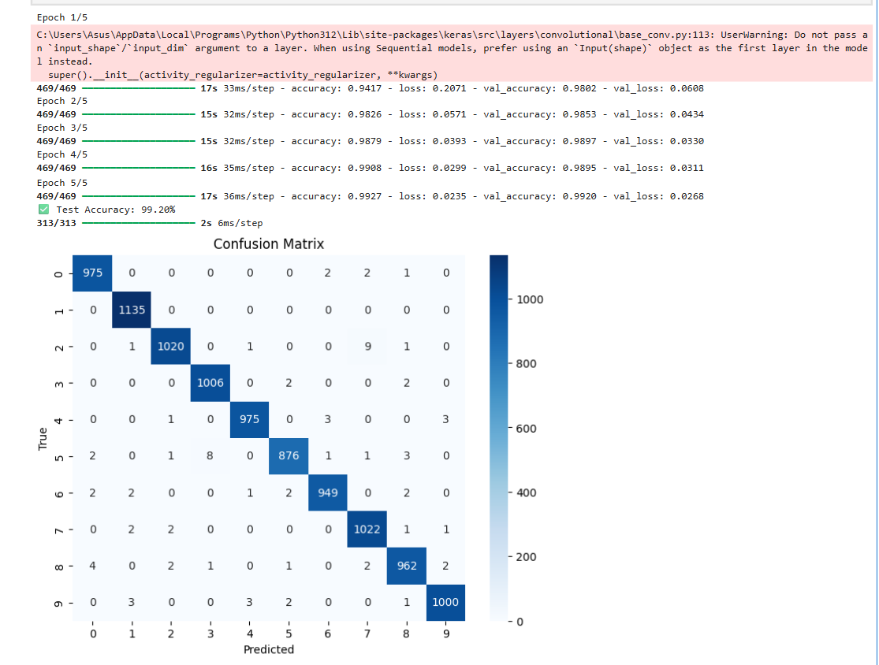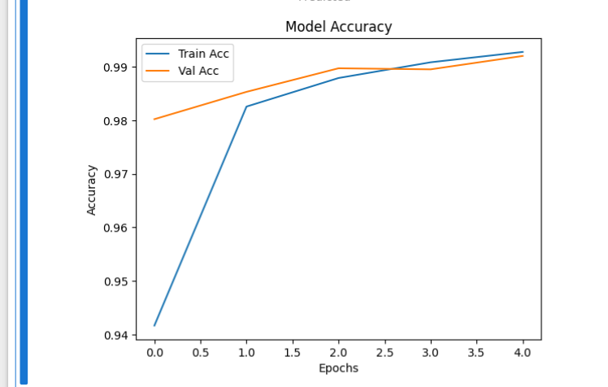

APP_TKINTER.PY

import tkinter as tk
import numpy as np
from PIL import ImageGrab
import tensorflow as tf

# Load your trained model
model = tf.keras.models.load_model("digit_model.h5")

# Create Tkinter window
window = tk.Tk()
window.title("Real-Time Digit Recognizer")

# Canvas for drawing
canvas = tk.Canvas(window, width=200, height=200, bg="white")
canvas.pack()

# Draw function
def draw(event):
x, y = event.x, event.y
canvas.create_oval(x, y, x+8, y+8, fill="black")

canvas.bind("<B1-Motion>", draw)

# Predict function
def predict_digit():
# Capture canvas as image
x = window.winfo_rootx() + canvas.winfo_x()
y = window.winfo_rooty() + canvas.winfo_y()
x1 = x + canvas.winfo_width()
y1 = y + canvas.winfo_height()
img = ImageGrab.grab().crop((x, y, x1, y1))

# Preprocess
img = img.resize((28,28)).convert("L")
img = np.array(img)
img = img.reshape(1,28,28,1).astype("float32")/255.0

# Predict
pred = model.predict(img)
digit = np.argmax(pred)
confidence = np.max(pred)

result_label.config(text=f"Prediction: {digit} (Confidence: {confidence:.2f})")

# Button + Label
predict_btn = tk.Button(window, text="Predict", command=predict_digit)
predict_btn.pack()

result_label = tk.Label(window, text="Draw a digit and click Predict")
result_label.pack()

# Clear canvas
def clear_canvas():
canvas.delete("all")

clear_btn = tk.Button(window, text="Clear", command=clear_canvas)
clear_btn.pack()

window.mainloop()

